**LABEL MAKER**

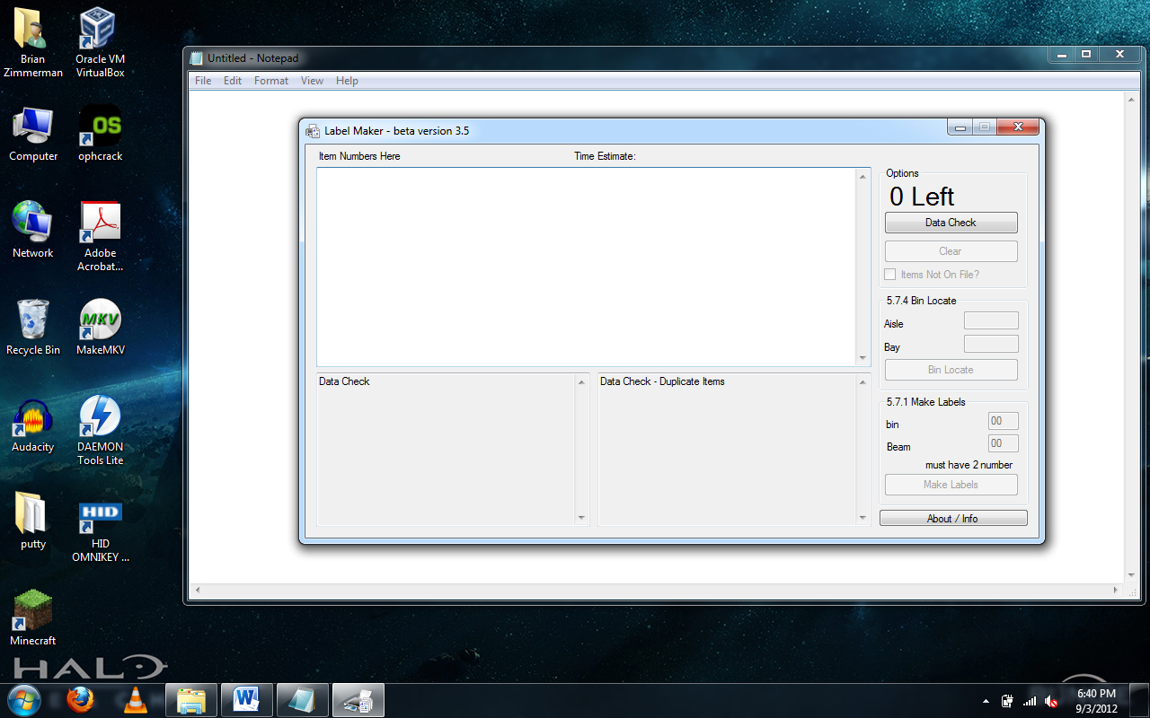

**About Label Maker**

* **Label Maker is a proof of concept** that there is an easier way to bin locate and queue labels from a raw planogram or list of items
* Is a huge time and hand saver
* If you were to bin locate during every reset you could save over 50 hours per store per week in time saved doing labels for resets, finding items for irps, pricing, order picking, and stocking then this would save the company over (1700 stores X 50 hours X 52 weeks X $10 average wage) $44,200,000.

**Label Maker Features**

* Will take in raw planogram data or item list and help you type for bin locating and queuing labels
* Types on the keyboard for you

**LABEL MAKER CHANGE LOG**

**Beta Version 1.0**

* Reads in item list and types bin location for you

**Beta Version 1.1 – Beta Version 3.2**

* Added support for reading selections of pog data
* Fixed label making function
* Fixed numerous other bugs

**New features in Beta Version 3.3**

* Built in data check to prevent most errors from occurring
* Built in duplicate item check
  + Will not bin locate the duplicates
  + Will make extra labels for duplicates
* Items not on file option
  + Will process bin locating and label making one item at a time to prevent not on file errors
* Added error checking to bin locate and make labels buttons to check for bad data in aisle, bay, bin, beam text boxes
* Added a clear button to clear the old item data to start a next bay

**New features in Beta Version 3.4**

* Built option to import POG with peg hooks
* Bug fixes

**New features in Beta Version 3.5**

* Auto data type detection (Supported types: POG, POG with peg hooks, item list)
* Option to add next page of the bay
* Added count down of labels processed when bin locating or label making

**New features in Beta Version 3.6**

* Added a stop button / box

**New features and changes in Beta Version 0.3.7**

* Data check will ignore displays listed on pog
* **Changed version number so that when this is out of beta it will be version 1.0**

**New features and changes in Beta Version 0.3.8**

* Data check will correctly read in raw pog data with peg hooks that has a another page

**New features and changes in Beta Version 0.3.9**

* Add option to the advanced option panel to check for missing label defaults

**New features and changes in Beta Version 0.4.0**

* Auto sorts by item location (can be disabled in advanced options)

**New features and changes in Beta Version 0.4.1**

* Added an update check and updater program to update Label Maker

**New features and changes in Beta Version 0.4.2**

* Per request/suggestion added the ability to use a 3 character aisle
* Clear button now also clears the Aisle and Bay fields
* Suggestion box under construction (future feature)

**New features and changes in Beta Version 0.4.3**

* Suggestion box now works
* Rewrote some code for faster execution

**New features and changes in Beta Version 0.4.4**

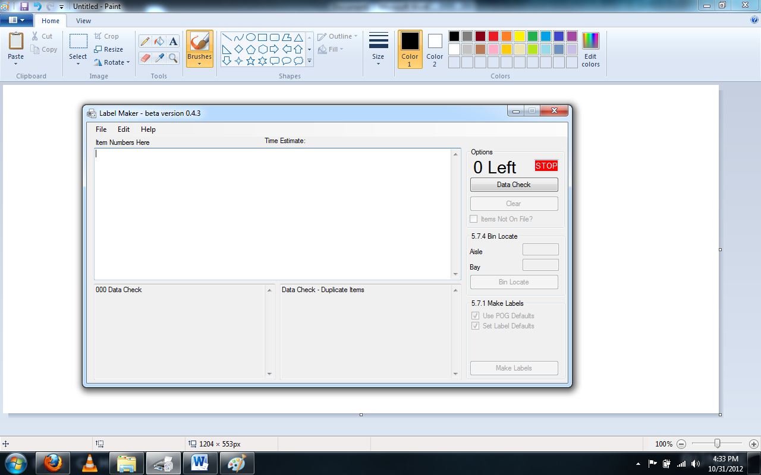

**Make Labels button will no longer ask you if you want to use the POG default.**

* It is now a check box and is check when the program runs.
* If you un check “Use POG Defaults” it will show you the options for Bin and Beam labels

**Added the option to not set the label defaults**

* It is check when the program runs
* Uncheck the “Set Label Defaults” if you are for an example doing pog for end caps

**Under the “Edit” menu click “Show Advanced Options” (Shown below)**

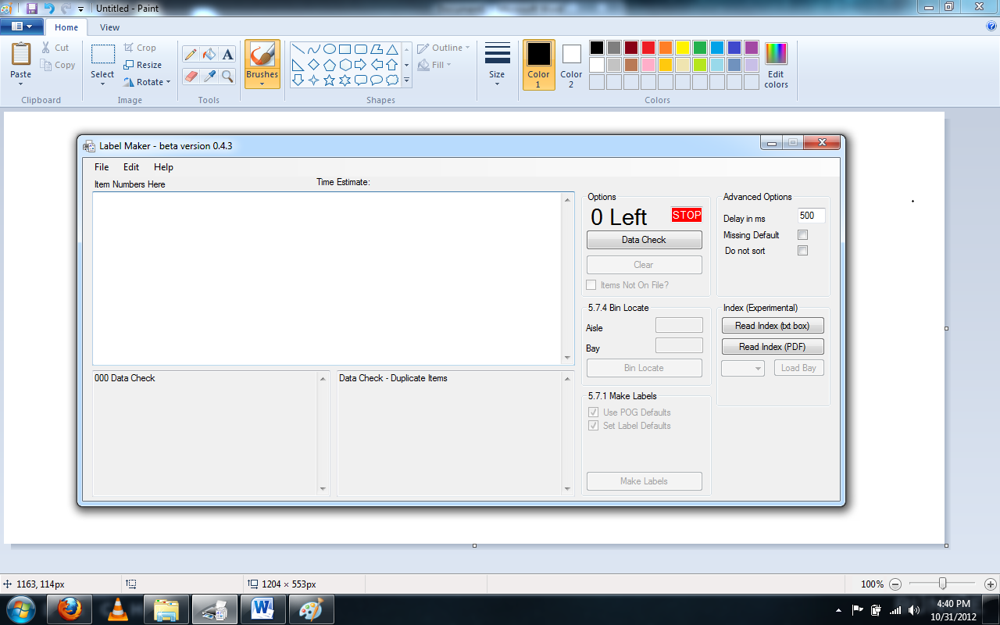

**Added “Read Index (txt box)” button**

* Reads copied index pages from the pog

**Added “Read Index (PDF)” button**

* Reads index pages from a PDF pog.
  + Prompts to open a pdf file
  + Reads index pages in
  + Use drop down box and “Load Bay” button to load the bay in for bin location and making labels

**LABEL MAKER INSTRUCTIONS**

**To Open Label Maker**

* Click on the **folder icon** bottom left on the screen
* Double click on the **S** drive
* Double click on **lowespad**
* Double click on **pricing**
* Double click on **label**
* Double click on **label maker**

**To Enter Index Page Data from a POG**

* Go to the first page of the Index
* **Select Data** from **POG Index** using **CTRL + A** on the keyboard and then **Press CTRL + C** on the keyboard
* Now **click** in the **text box** of **label maker** and **Right Click** and select **paste OR CTRL + V** on the Keyboard
* Click on **“Read Index (txt box)”** button
* If you have another page to the index answer yes to **“Do you want to enter another page?”** and **repeat the three steps above on the next page of the POG index**

**To Open Index Page Data from a PDF POG**

* Click on **“Read Index (PDF)”** button
* Select a PDF pog file

**To select a bay to Binlocate or Make Labels from POG Index**

* Click on the drop down box next to the **“Load Bay”** button and select the bay you want to work with
  + Then click the **“Load Bay”** button
  + Binlocate and Make Labels as per the instructions below
  + When ready for the next bay repeat this section of instructions

**To Enter Data from a POG**

* Open a **POG**
* **Select Data** from **POG** using **CTRL + A** on the keyboard and then **Press CTRL + C** on the keyboard

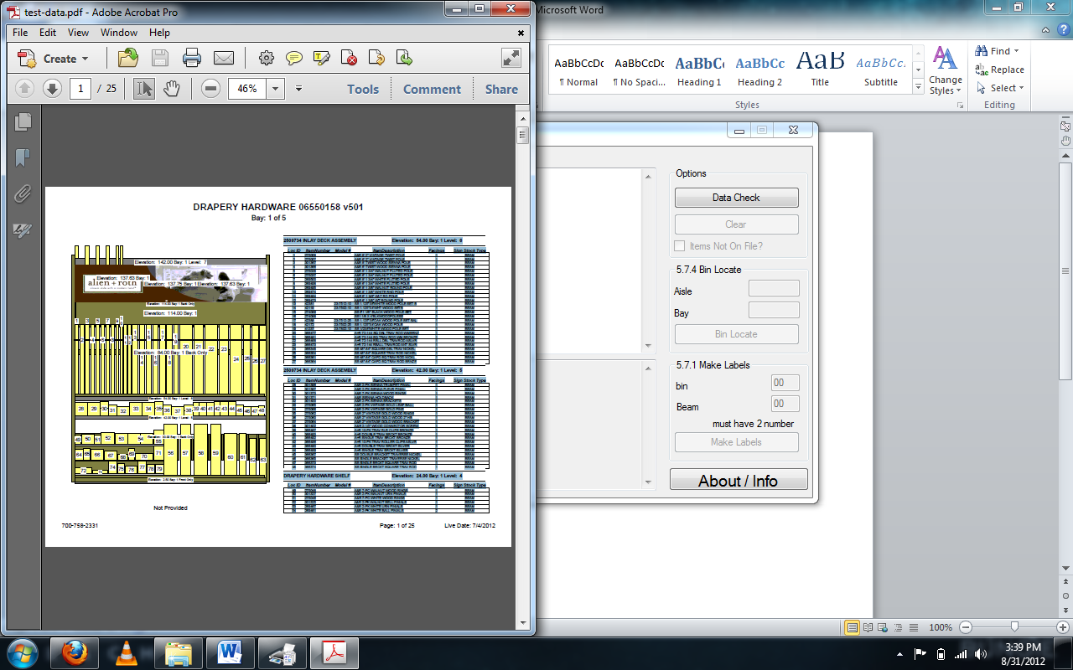

* Now **click** in the **text box** of **label maker** and **Right Click** and select **paste OR CTRL + V** on the Keyboard

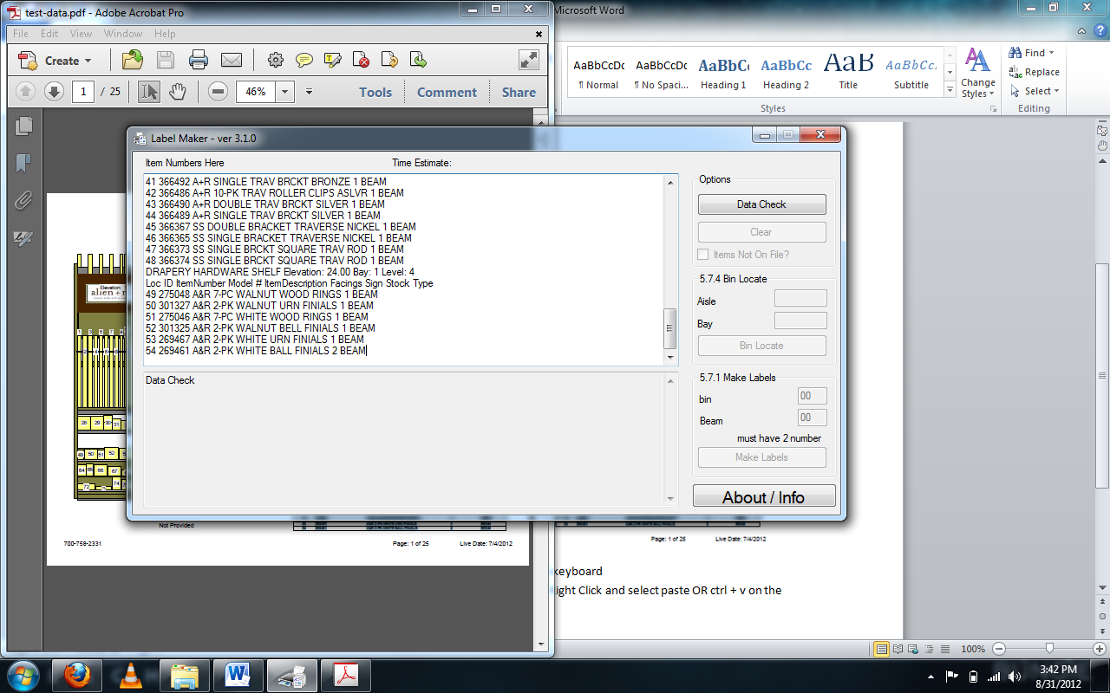

* Now click **Data Check**
* If you have another page to the bay answer yes to **“Do you want to enter another page (same bay only)?”**and **repeat the two steps above on the next page of the POG**
  + - If you do not have another page to the bay answer no to **“Do you want to enter another page (same bay only)?”** and continue to **Bin Locate** or **Make Labels**

**Bin Locate**

* Fill out the Aisle and Bay
* Click on **Bin Locate**
  + If no error continue next step
* You have **6 seconds** to click on the **5.7.4 screen**
* **Do not move the mouse or touch the keyboard till it display the done message**
* If you run across an item that is not on file let the program finish and select **Item Not On File** and restart the Bin Locate

**Make Labels**

* If you do not want to use the POG default Un check “Use POG Default” and Fill out the bin and beam
* Click on **Make Labels**
* You **have 6 seconds** to click on the **5.7.1 screen**
* **Do not move the mouse or touch the keyboard till it display the done message**
* If you run across an item that is not on file let the program finish and select **Item Not On File** and restart the Make Label
* Now go print you labels as normal

**When Done with Bay or POG**

* **Click** on **Clear** to clear the bay and you can start the next bay or pog